LSTM Result:

From 3550 to 3650

Look back = 7

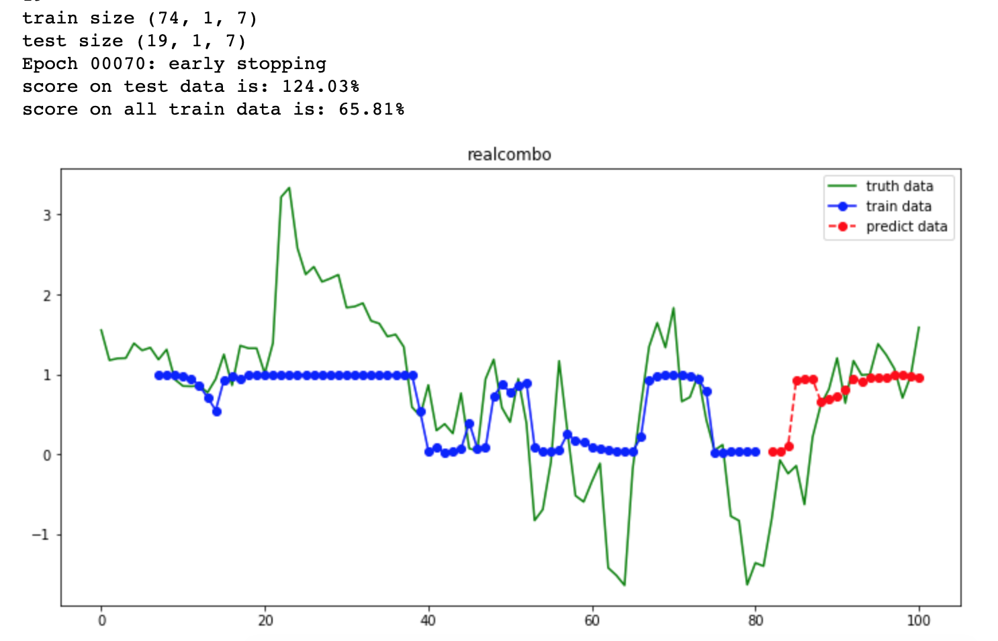

look back =5

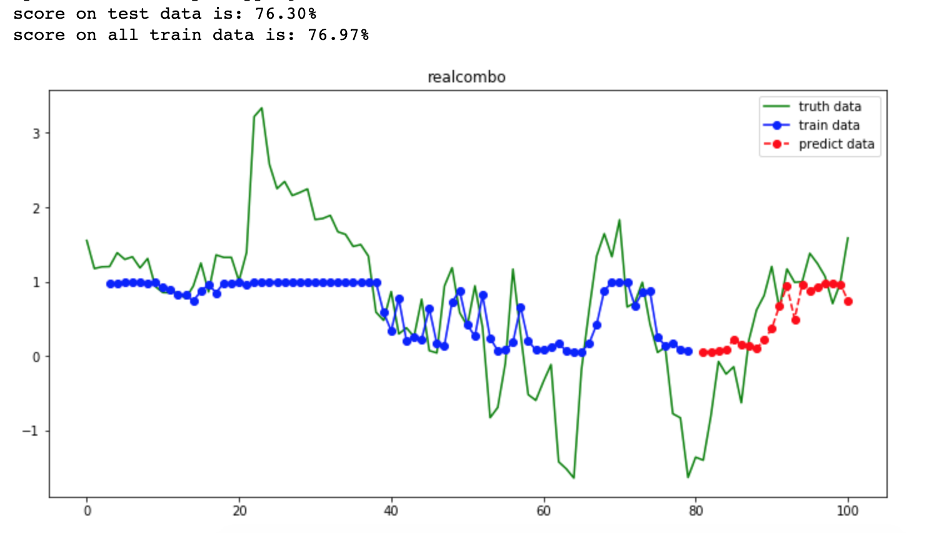

look back = 3

